A266-Afr-Egy-Ushabti-Saite Period-26th Dynasty, 664–525 BCE-Hieroglyphs-Faience

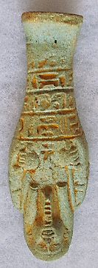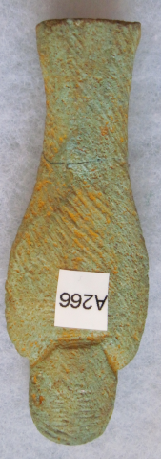

**Case No.: 2**

**Formal Label:** Ushabti-Saite Period-26th Dynasty, 664–525 BCE-Hieroglyphs-Faience

**Display Description: Plain lappet wig with single bands, plaited beard, hands crossed opposite sleeves combined, arms not indicated, right hand grasps a pick, left hand grasps a hoe, three registers of hieroglyphs**

**Accession Number: A266**

**LC Classification:** DT62

**Date or Time Horizon:** Saite Period, 26th Dynasty, 664–525 BCE

**Geographical Area: Sais, Egypt**

**Map, GPS Coordinates:** 30.96650 30.76751, 30º57'59.41" N 30º46'3.02" E

 

Fig. Left. Sais on the Nile after http://latitude.to/lat/30.96606/lng/30.76785. Fig. Sais reconstructed according to Jean-Claude Golvin, http://jeanclaudegolvin.com/sais-2/.

**Cultural Affiliation:** Saite Period, 26th Dynasty, 664–525 BCE

**Medium:** blue glaze over clay

**Dimensions: H 85.73 mm; 3.372 in  
Weight: 25 gm; .75 oz**

**Provenance: unknown**

**Condition:** original

**Discussion:** Psamtik I, ruled 664–610 BCE, commanded a loose confederation of twelve Egyptian territories, based on the traditional nomes or territories (*spAt*, in Egyptian), and the rise of Psamtik I in power, establishing the Saitic Dynasty, which is recorded in Herodotus's *Histories* (Bk II: ll. 151–157). Twenty local princelings were appointed by Esarhaddon (king of the Neo-Assyrian Empire who reigned 681 – 669 BCE) to govern Egypt. This Ushabti therefore confirms owner’s allegiance to Psamtik I and not the Neo-Assyrian Esharhaddon.

**References:**

Aubert, J.-F. et L. Aubert. 1974. *Statuettes Egyptiennes: Chaouabtis, Ouchebtis.* Paris, 1974), p. 217, 234, 279-281;

Janes, Glenn. 2002. *Shabtis. A Private View, Ancient Egyptian Funerary Statuettes in European Private Collections.* Paris: Cybèle.

Newberry, Percy E. 1930-1957. *Funerary Statuettes and Model Sarcophagi*.  Le Caire: Impr. de l'Institut français d'archéologie orientale.

Schneider, Hans D. 1977. *Shabtis - An Introduction to the History of Ancient Egyptian Funerary Statuettes. With a Catalogue of the Collection of Shabtis in the National Museum of Leiden*. (3 volumes, Leiden: Rijksmuseum van Oudheden Te Leiden.

Schlögl, Hermann and Andreas Brodbeck. 1990. *Ägyptische Totenfiguren aus öffentlichen und privaten Sammlungen der Schweiz.* Orbis Biblicus et Orientalis, Series Archeologica, 7. Göttingen, Vandenhoeck & Ruprecht; Freiburg Schweiz, Universitätsverlag.